OHM'S LAW

This law relates the voltage, current and resistance in a circuit.

Ohm's Law: Provided the temperature remains constant, when a voltage is applied to a given
resistance, the greater the voltage, the greater the current that flows.

Note: If the wire gets hot, the resistance changes (it increases)!

This law is expressed by the following equation.

V = I R

The following equation triangle can be used to do mathematical calculations based on this law.

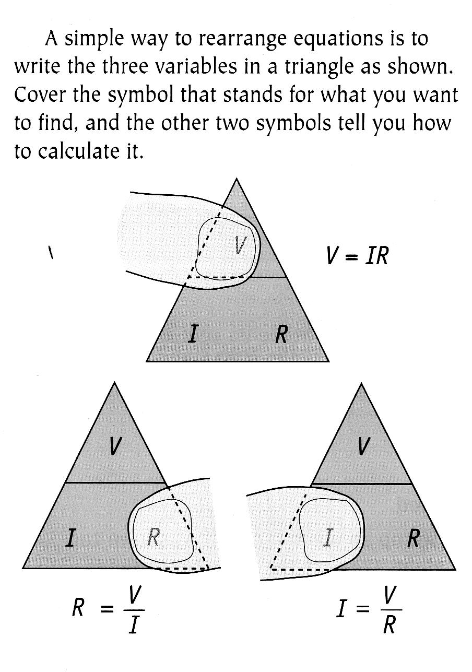
V
I
R

EXAMPLES

1. A current of 4.5 A flows through a resistor of 100 Ω. Calculate the voltage applied to the
resistor.
Set your working out clearly.

• Equation
• Substituted numbers
• Answer
Write the data down on the left hand side.

2. If a 1.5 V cell is connected to a globe with a resistance of 10 Ω, what current will flow
through it?

3. A room heater working on 240 V uses 5.0 A of current when it is set on its highest setting.
What is the resistance of the heater coil inside the machine?

